3 Ways for Client to View Ticket After Submitting
- Click the “View the request you just created” link in “Request Created Successfully” window that opens right after the ticket is submitted. | 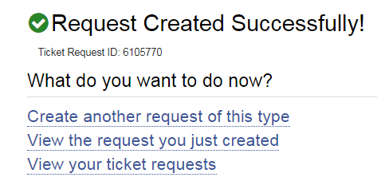
- Click on ticket number link in the response email received after ticket is submitted. | 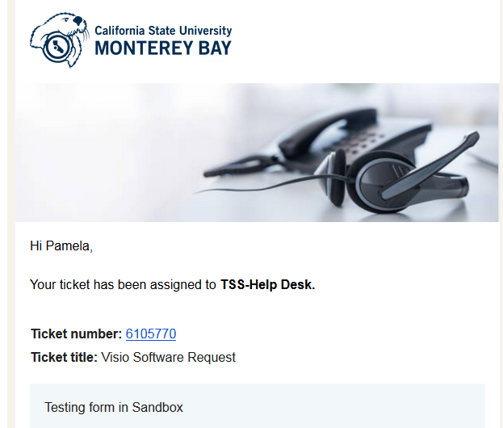
- On TDx home page click Services, then click Ticket Requests in submenu to view all ticket requests.  The list is defaulted to view only “New, In Process, and On Hold” tickets, however, you can use the Status Class filter to view any or all statuses.  There are other search and filter options as well. | 